 | Presentation of the connected hive project | 
Mission:
A Danish delegation from Christianshavn high school in Copenhagen will be visiting our school between Monday March 24th and Friday March 27th 2020.
During this one-week stay, the connected hive project will be presented to them. Indeed, in 2021, the Danish high school will be equipped with a connected hive system created by our students.
(A beehive with the Danish flag has been installed in 2019 on the balcony of the CDI).

Touchard high school has already installed two hives in the school in order to raise the pupils’ awareness towards environmental issues such as the decline of biodiversity. Different teachers supervise this project which serves among other things as an educational tool for the BTS SNIR.
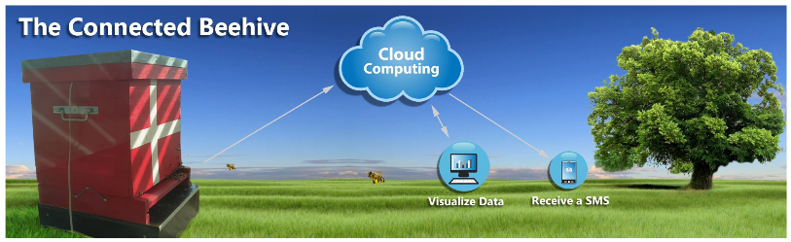
Description of the project :
Currently, it is difficult to anticipate the depopulation of hives. The presumed causes can be pesticides, varroa (mite), diseases and Asian hornets. Thus, to tackle this problem, real-time monitoring of certain hive parameters could help anticipate and predict this situation.
The connected hive system was commissioned in June 2019 and has been operating continuously since then. In its current version, the system is powered by POE; the data is stored in Matlab's Thingspeak cloud computing system.
In the future, the system will require an autonomous power supply (photovoltaic panel and battery). The solar panel will have to follow the position of the sun for more energy efficiency.
Easy and quick to install, the system can be positioned under any beehive and it provides real-time monitoring of measured quantities. Graphs and data analysis can be checked on a website. These data contribute to help keep an eye on the health of the bee colonies. If necessary, an SMS alert gives a warning signal for a recurring event such as:
- excessive temperature inside the hive
- abnormal increase or decrease in the hive’s weight.

A weekly report is sent by e-mail. This report contains a summary of the observations. It presents the averages, standard deviations, and patterns in the increase or decrease of recorded measurements. Data transmission via the GSM network is particularly suitable when the measurements are carried out on a hive in an isolated and remote location. A GSM modem will be used. The system must be autonomous (as long as possible) in energy in order to be installed in an isolated place (an autonomy of 15 days in cloudy weather). When the battery charge rate is too low, the system falls asleep. It wakes up when the battery is sufficiently reloaded.
While a geolocation probe can be used for scientific purposes, this object is mainly used as an anti-theft device by beekeepers. Indeed, beekeepers are more and more and more frequently having their hives stolen. The large loss of hives and the high price of colonies is a problem for beekeepers. The beekeeping industry is therefore looking for ways to fight against these thefts.
To conclude, this project consists in creating:
- an autonomous energy supply system
- and a data aggregator

Synoptic:

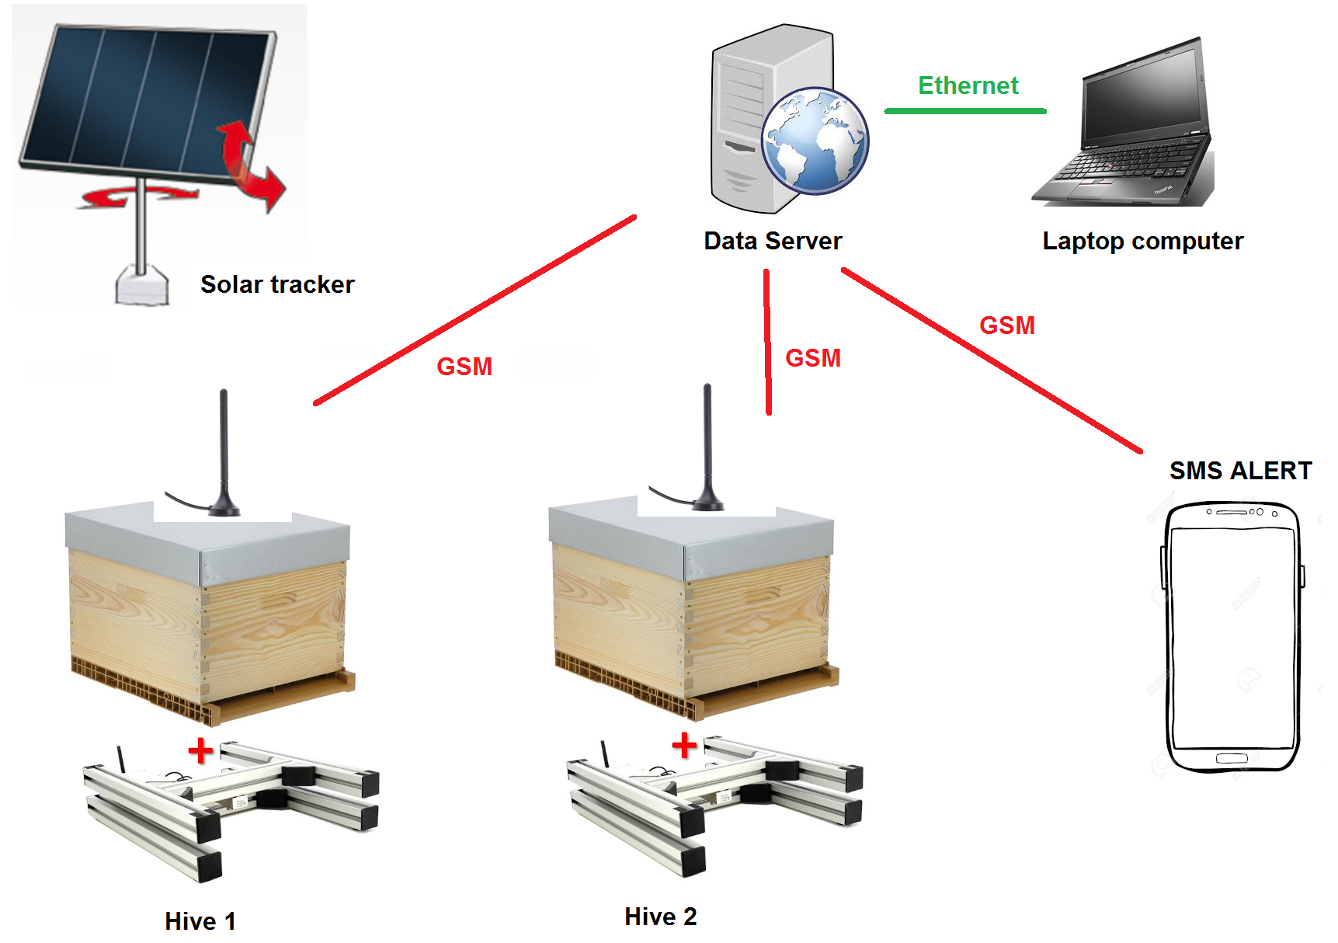

Actors | Goal
Users | Internet users can consult the recorded data. The concerned user receives an SMS alert when any abnormal condition is detected
Administrator | The administrator can enter information about a user and the installation of a new connected hive.
Hive | Receive or archive data such as Battery Charge Level (SOC), battery voltage and current. Measure the hive’s weight, temperature, humidity and air pressure.
Sun | Gives the orientation that the photovoltaic panel must have thanks to an electric actuator.

Tasks:

Prepare a PowerPoint presentation (2 slides per pair) :

Pairs | Parts
Yoann Louis | Presentation of a hive. Characteristics (number of bees, quantity of harvested honey, etc.)
Charly Tom | The environmental issues of a hive.
Axel Quentin | Why add an electronic tracking device?
Ouijdane Gurvan | Description of the Synoptic.
Dylan Baptiste | Relationship with the CDI’s hives
Sofiane Léo | Presentation of the website  http://touchardinforeseau.servehttp.com/beehive
Théo Melvyn | What is the POE ?
Damien Ahmed | Role of a solar tracking system
Maëva Antoine | Importance of Raspberry Pi in the system
Pierre Thomas | Why measure the electric current consumption?
https://github.com/nathanderouelle/Projet_Ruche
Students to be placed by pairs in the above grid:

BERNARD Pierre  BOUGEOT Louis  BOURGOUIN Charly  BRAULT Quentin  CABARET Damien  CHAUBET Gurvan  COGNARD Léo | CORBIN WAGER Thomas  DOMINGOS Axel  GIRARD Melvyn  GRAMMONT Dylan  GUITTON Baptiste  IMER Ouijdane  LANGLAIS Théo | LETESSIER Yoann  PACOT Antoine  RENAUDIN Tom  SABRI Sofiane  SOULARD Maëva  YOUSFI Ahmed

